QUESTION 2 -
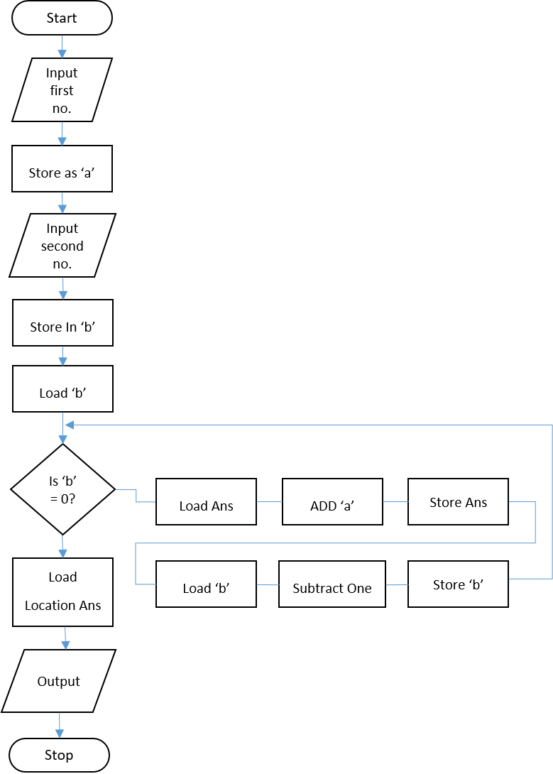

a) LMC MULTIPLICATION
The LMC can add or subtract numbers, but it can neither multiply nor divide. The multiplication can be carried out using addition.
Here, is how it works;
2 x 3 = 6
so, 2 + 2 + 2 = 6
3 x 4 = /12
so, 3 + 3 + 3 + 3 = 12
So, with the benefit of a loop we keep adding the first number as many as the second number times.

RESEARCH SOURCE: http://www.computinglesson.com/the-little-man-computer.html (Ctrl and click to visit referenced website)
My flowchart has been influenced by the flowchart on this website, which addresses the same multiplication execution.

b) PLAN LMC MULTIPLICATION - ALGORITHM
PSEUDOCODE: FLOWCHART:
INPUT A
INPUT B
IF B == 0
Print(B)
ELSE
WHILE B! =0
A = A + 1
B = B – A
ELSE
OUT(A)
END IF
END

Research Source: http://www.vivaxsolutions.com/web/lmc.aspx (Ctrl and click to visit referenced website)

Figure 3: This is a screenshot displaying the code, created, after making the algorithms. This code will work out multiplication, using addition. The loop has been added so that the user is able to input two numbers that they wish to multiply.

C) WRITING THE PROGRAM AND DEMONSTRATION

DEMONSTRATION
On the following page, I have included screen shots which demonstrate the code above. This will show how the code is able to calculate multiplication, with input given from the user.
The expected outcome is that the code should take the two inputted numbers and multiply the first number by the second number. Given that LMC cannot multiply numbers, the program uses addition. (For more information, please see part A) LMC multiplication on Page 13)
SCREENSHOTS ON FOLLOWING PAGE: The two numbers that were inputted into LMC. were 15. So as the first number that was inputted (figure 4) was 15 and the second number, also 15, the program will carry out 15+15… (Fifteen times), and will output 225, which is 15 x 15. (Figure 5)

Figure 4: This is a screenshot of LMC, showing the program prompting the user to input a number. The user has inputted 15.
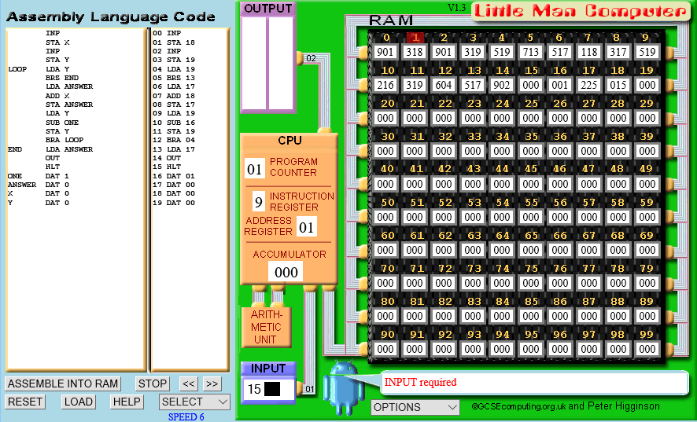

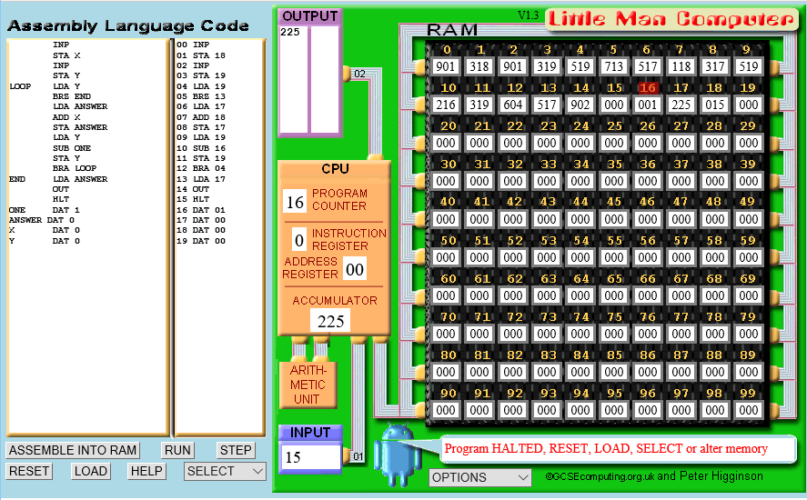
Figure 5: As you can see in this screenshot, after the second number (15) has been inputted and the output is 225.

We can also see that the addition was successful as the program counter is 16. The count is initially 15, but as the program counter started at 1 (shown in figure 4) it ends at 16, leaving a count of 15 between them, therefore showing the number was added 15 times.

