**The Cold War 1945-1975**

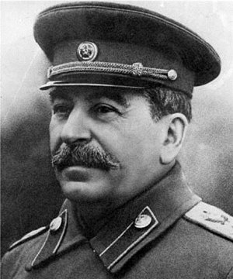

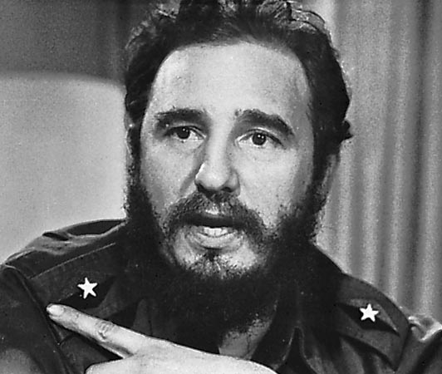

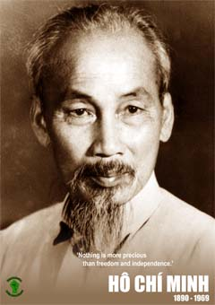

Revision check list

|  |  |  |  |
| --- | --- | --- | --- |
| **Topic** | Notes? | Understand? | Confidence /10? |
| What agreements were made at Yalta? |  |  |  |
| What changes had taken place by the time of Potsdam?? |  |  |  |
| What did the leaders disagree about at Potsdam? |  |  |  |
| What were the main reasons that the USA and USSR fell out? |  |  |  |
| What was the Iron Curtain? |  |  |  |
| What were ‘Salami Tactics’? |  |  |  |
| What was the USA’s response to the USSR’s takeover of Eastern Europe? |  |  |  |
| What was the Berlin Blockade? Causes, events, consequences |  |  |  |
| What was NATO and why was it set up? |  |  |  |
| Who was most to ‘blame’ for the Cold War? |  |  |  |
| Why was the Korean War significant? Causes, events, consequences |  |  |  |
| Who controlled Cuba before the 1959 Castro Revolution? |  |  |  |
| Why did the USA and Castro fall out? |  |  |  |
| What was the Cuban Missile Crisis? |  |  |  |
| How was it resolved and who ‘won’ the Crisis? |  |  |  |
| Why did the USA get involved in events in Vietnam? |  |  |  |
| What tactics did the USA use to fight the war? |  |  |  |
| What tactics did the Vietcong use to fight the war? |  |  |  |
| What was the Tet Offensive (1968) and why can it be seen as a turning point in the war? |  |  |  |
| Why did US public opinion turn against the war in Vietnam? |  |  |  |
| How did the war in Vietnam end? Consequences and legacy |  |  |  |

**COLD WAR: 1945-49 – REVISION NOTES**

Walsh p.318-335 sh

**Agreements at Yalta (Feb 1945)**

1. **Stalin accepted France** as one of the four powers.
2. **Germany was to be divided into four zones** (USA, USSR, Britain, France). **Berlin – in the Russia sector – was also to be divided into four sectors**.
3. **Poland would get land from Germany and lose land to the USSR**. *This basically meant that Poland moved West after WW2.*
4. The USSR would declare war on Japan 3 months after the end of the war with Germany.
5. **Stalin promised to allow free elections in the East European countries** the Soviet army was occupying.

**Changes by Potsdam (Jul-Aug 1945)**

1. **Stalin’s armies were now occupying most of Eastern Europe…** *Stalin said he needed to control Eastern Europe to guard against future attacks*.
2. **New leaders** – FDR died and was replaced by anti-Communist Harry S. Truman; Churchill lost an election and was replaced by Clement Attlee half-way through Potsdam.
3. **The US now had the atomic bomb**…

**Disagreements at Potsdam**

* **Germany** – Stalin wanted to cripple it; Truman didn’t wanted to repeat mistakes of ToV.
* **Reparations** – Stalin wanted heavy compensation for 20m Soviet deaths & war damage to USSR; Truman refused… Stalin got some goods but no cash.
* By Potsdam it was clear that Stalin’s “**free elections**” in E. Europe would not be “free”… but FDR & Churchill *had* agreed at Yalta that E. Europe was Russia’s “**sphere of influence**”

--------------------------------------------------------------------------------------------------------

**Reasons the 2 sides fell out…**

|  |  |  |
| --- | --- | --- |
| USA believed USSR wanted to spread Communism. (It did). | USSR believed USA wanted to spread capitalism. (It did). | Capitalism vs. Communism + the size of USSR made it a rival to the USA |
| USA didn’t tell USSR about their atomic bomb until they were about to use it | Only united when they had a common enemy – Nazi Germany | Death of FDR. He was wary of Stalin but had a good relationship with him. |
| Stalin thought USA & UK made USSR do most of the fighting against Germany – thought US’s aim was to weaken USSR ahead of WW2 ending… | | “Aggressive” USSR takeover of Eastern Europe 1945-48  (see below) |

--------------------------------------------------------------------------------------------------------

**IRON CURTAIN**: As early as 1946 it was clear the wartime alliance was over. Churchill made his famous speech about an “**Iron Curtain**” dividing free Europe in the West from Communist Europe in the East.

“**Salami tactics**” = USSR policy of getting rid of the anti-Comm. opposition bit-by-bit in E. European countries after WW2. Anti-Comm. leaders were imprisoned and murdered. By **1948 USSR controlled all of E Europe except Greece**.



--------------------------------------------------------------------------------------------------------

**USA response to USSR takeover of E Europe…**

**1947 – TRUMAN DOCTRINE**: US promised money, arms & advice to countries “threatened” by Communism. (The US wanted to **CONTAIN** Communism & stop it spreading)

**1948 – MARSHALL PLAN**: $17bn of aid to help European countries recover from WW2 [Why? (i) help out these countries; (ii) protect & create foreign markets for US goods]. US Congress (Parliament) initially opposed the Marshall Plan but changed its mind after Communists took over Czechoslovakia in 1948.

**Greece 1947** – a Civil War broke out between Communists and Monarchists (who supported the Greek King). Britain helped the monarchists but said it could not afford the cost of the war and threatened to leave. US agreed to pay for the costs of the British troops. Result = Greece stayed non-Communist (although with a very weak Government).

--------------------------------------------------------------------------------------------------------

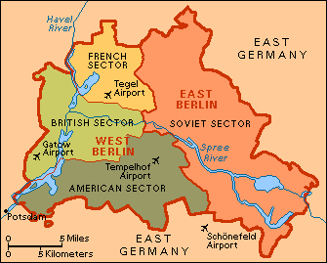

**Berlin Blockade Jun 1948 - May 1949**

* After Germany was defeated it was divided into 4 zones, which the allies would administer while deciding what to do with it. The US, Br & Fr zones were in the West; the USSR zone was in the East.
* **Berlin was in the Russian zone**, but because it was the capital it was also divided (W Berlin = Br, Fr, US; E Berlin = USSR).
* The allies had agreed that they would make all decisions about Germany’s future together, but in 1947-48 US, Br & Fr started making decisions about the future of the Western Zones without involving the USSR. 1947 – W. zones were merged into 1 zone; 1948 - a new currency was issued in the W. zones.
* Stalin saw this as **provocative** – it broke earlier agreements at Potsdam – and he was also worried about the economic recovery of Germany in the Western zone.
* In a clever move in **June 1948** he cut off road and rail supplies from Western-administered Germany through USSR-administered Germany into West Berlin. **He probably hoped to force the Western allies to leave West Berlin**. Had the allies tried to force through the blockade it might have started a war… so, instead, the allies flew in all the supplies that West Berlin needed to survive (“the Berlin airlift”.)
* Stalin *could* have shot the planes down but did not as he did not want a war. By May 1949 it was clear that the allies would not give up W. Berlin so Stalin ended the blockade.
* **Berlin set a pattern for the CW: both sides were suspicious of and determined to stop the other; but they also did not want to go to war *directly* with one another.**

**CUBAN MISSILE CRISIS – REVISION NOTES**

Walsh 347-352

**Before the Castro Revolution of 1959**

* Cuba is an island 100 miles (160KM) away from Florida in the USA.
* It had been an ally of the USA for a long time. The Cuban ruler until 1959 was **Batista**; he was a dictator but had US support because he was anti-Communist.



**Fidel Castro**

* Until 1959 Americans owned most of the businesses on Cuba.

**1959-1961: the US & Castro fall out**

* The relationship between the US & Castro was frosty, but initially there was no direct confrontation.
* Castro took over US businesses on Cuba but let the Americans keep their naval base.
* But by 1960 Castro was receiving arms from the USSR and America knew this.
* Jan 1961 – the US broke off diplomatic relationships with Cuba. Castro thought the US was going to invade.
* April 1961 – JFK gave arms and money to **1,400 anti-Castro exiles** to invade Cuba. They land at the **Bay of Pigs** where **20,000 Cuban soldiers** were waiting for them. Castro’s army won an easy victory. The US’ attempt to kick Communism out of Cuba had failed.

|  |  |
| --- | --- |
| USA had miscalculated by supporting the hated Batista in the first place… | Bay of Pigs failure made JFK look weak… |
| Bay of Pigs failure prob strengthened Communism in Cuba… | … it also made the USSR give Castro even more arms! By summer ’62 it had the best army in Latin America! |

--------------------------------------------------------------------------------------------------------

**October 1962: The Cuban Missile Crisis…**

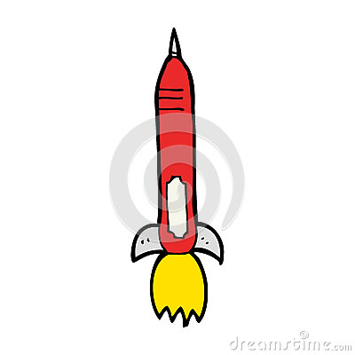

- … in Sep ’62 the US warned the USSR that it would take “whatever means 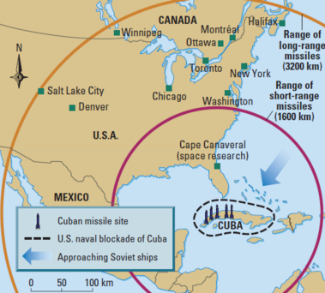necessary” to protect itself if the Russians put nuclear missiles on Cuba…

- on 14 Oct ’62 a US U2 spyplane took photos of nuclear missile sites on Cuba…

- worse still American spy planes reported that 20 Soviet ships were on their way to Cuba

*This map shows why the Americans were so worried about Soviet nuclear weapons being placed on Cuba*

**The options available to JFK** *look at p.349 to help you complete the grid*

|  |  |  |
| --- | --- | --- |
| **Option** | **Arguments for** | **Arguments against** |
| Do nothing |  |  |
| Surgical Air Strike |  |  |
| Invade Cuba |  |  |
| Diplomatic pressure through the UN |  |  |
| Blockade (stop the ships from reaching Cuba) |  |  |

**What happened next?**

1. 24 Oct: the Blockade began…

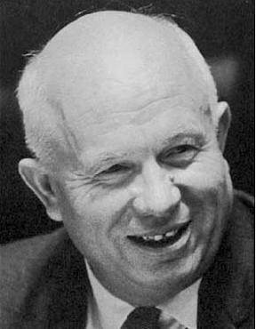

Khrushchev

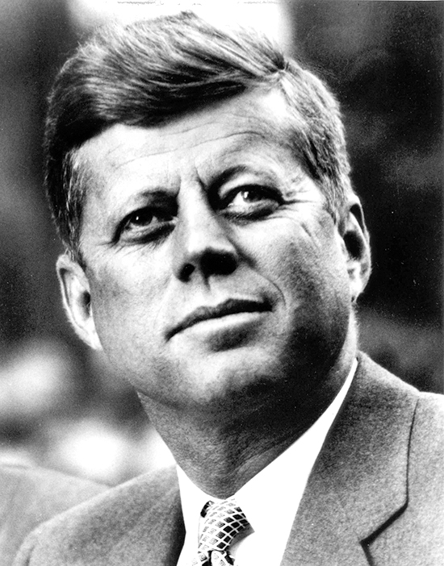

JFK

1. 26 Oct: 1st Khrushchev letter to JFK – *USSR will remove missiles if US promises to leave Cuba alone*
2. 27 Oct: 2nd Khrushchev letter – *demands US to remove missiles from Turkey also*
3. 27 Oct: A US plane is shot down over Cuba… war seems likely… but JFK replies to 1st letter, accepting Khrushchev’s terms
4. 28 Oct: Khrushchev agrees to remove missiles…

------------------------------------------------------------------------------------------------------

**Why did Russia put missiles on Cuba?** (i) to test JFK; (ii) to bargain [get US missiles out of Turkey]; (iii) to even out the arms race [US had bases next to Russia from which it could attack Russia before Russia had a chance to respond]; (iv) to defend Cuba

------------------------------------------------------------------------------------------------------

|  |  |  |
| --- | --- | --- |
| The outcome | Cuba stayed Communist and highly armed – but with no Russia nukes… | Cuba remained a useful ally for Russia in “America’s backyard” |
| USA-USSR relations improved – a hot line was set up between the 2 leaders to make future crises easier to solve | **Khrushchev (+)** … for most Russians he came out of the crisis as a “responsible peacemaker”  He also got a secret deal with the US to remove their missiles from Turkey  **Khrushchev (-)** … the West & some Communist leaders in Russia thought he’d been forced to back down  - 2 yrs later he lost his job as Soviet leader |
| **JFK (+)** … was seem as the “winner” by the Western world – he had stood up to the USSR & got the missiles removed  **JFK (-)** … Cuba stayed Communist  Containment failed to stop Communism arriving in the Americas |

**Vietnam War – revision notes**

Walsh P. 353-365

**Background to the war…**

1. Vietnam had been a French colony but was seized by Japan in WW2.



**Ho Chi Minh**

1. During WW2 **Ho Chi Minh** led Communist resistance fighters – the **Viet Minh** – against the Japanese. At the end of WW2 the Viet Minh announced Vietnamese independence…
2. … but the French had other ideas and returned to Vietnam.
3. In 1949 Communists took over in China. Fearing that neighbouring countries would fall like **DOMINOES** to Communism, the US gave France $500m/yr to set up an anti-Comm government in S. Vietnam.
4. In 1954 the French were finally defeated by the Viet Minh at **Dien Bien Phu**. At the following peace conference in Geneva Vietnam was divided in N & S Vietnam (N = Comm; S = anti-Comm) until elections could be held to decide its future.

**US involvement ramps up…**

|  |  |  |
| --- | --- | --- |
| Early 1950s – US already paying France $500m/yr to support fight vs. Communism | **1954** – **US prevents elections** because it is worried Ho Chi Minh will win! | **1955** – US helps **Ngo Dinh Diem** set up the **Republic of South Vietnam** [anti-Communist]; gives Ngo $1.6 billion in aid in 1950s |
| **1962** – S. Viet. under increasing attack from **VIET CONG** (Viet Minh fighters in S. V). – US sends “**combat advisors**” to help | 11,500 US “combat advisors” by end 1962; 23,000 US “combat advisors” by end 1963 | 1963 – JFK shot; LBJ takes over  **Aug 1964 – Gulf of Tonkin incident** (NV boats fire on US boats → **war begins**!!!) |

**US tactics**

|  |  |  |
| --- | --- | --- |
| **Policy** | **Aim** | **Impact** |
| **Strategic Hamlet Prog 1961-63** | Move SV peasants into fenced-in villages to protect them from the VC. | Huge failure. SV peas very angry at being “kept prisoner”. VC member-ship goes up 300%(!!) – prog stopped |
| **Bombing** | Op Rolling Thunder. Bomb VM/VC into submission. Destroy their bases and supply lines. | Lots of VM/VC killed… but huge civilian deaths too. Turns people against US; also v. costly $400K for each VC killed! |
| **Chemical Weapons** | Agent Orange (weedkiller); Napalm (incendiary). Aim = destroy guerrilla hideouts. | Huge civilian deaths and injuries. Also, weapons caused birth defects. Turned S Vietnamese peasants against US. |
| **Search & Destroy** | Raiding parties to kill VC forces. | US parties often walked into traps. Innocent villagers often died: 6 people killed per VC captured. Again, pushes villagers away from US. |

**Viet Cong & Guerrilla tactics**

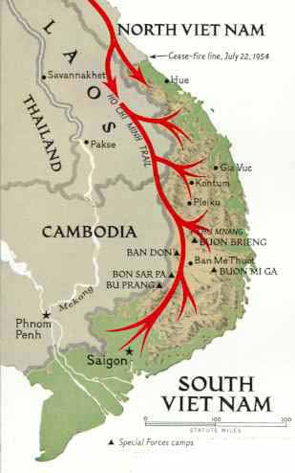

**TRAIL –** Ho Chi M supply line: from NV, through Laos & Cambodia, then into SV

**TRAPS** – hidden everywhere and smeared with poison & faeces…

**TUNNELS** – huge underground networks which the US generally couldn’t find

**BIGGEST STRENGTH = refusal to give in.** The Viet Minh and Viet Cong weren’t really fighting for Communism… they were fighting to defend their country against a foreign invader who was killing millions of their countrymen.

**The Tet Offensive – 1968 – A turning point?**

**What was it?** A way for the Comms to take the fight to the US. It was a series of staged VC uprisings in different cities in S. Vietnam. Even the US Embassy in Saigon was attacked.

**Did it work?** On the face of it, no. US forces quickly regained control and the VC lost 10,000 experienced fighters, badly weakening them.

**But…** it looked like a defeat to theUS public. US was spending $20bn/yr on the war and not even the US Embassy was safe! US public opinion started turning against the war.

**US public opinion turns against the war – key events…**

|  |  |  |
| --- | --- | --- |
| **1968 – Tet Offensive** | **1969 – My Lai massacre** of 1968 (in which 300-400 civilians killed) was **exposed**. | **Anti-war protests**: “Hey! Hey! LBJ! How many kids did you kill today”) |
| **Famous photos** – Phan Ti Kim Phuc (napalm girl); Quang Duc (monk); SV police execution | **1970 – Kent St University massacre**: guards shoot & kill 4 at anti-war protest | **Rising US body count**… many thousands dying each year (c. 60K in total) |
| Unlike previous wars, the **US public saw the war “live” on their TVs**, & they didn’t like it. | | |

**Ending the war…**

* In 1968 LBJ stepped down. The new President, Nixon, was committed to ending the war.
* Nixon pushed hard to **VIETNAMISE** the war… this means getting the South Vietnamese to do their own fighting…
* … but at the same time, to try to improve his bargaining hand, he **INCREASED BOMBING** on Vietnam, even attacking VC forces in neighbouring Cambodia!
* Nixon also improved the US’s relationship with China. The aim of this was to use Chinese influence on Vietnam to end the war.
* →→→ eventually, in **Jan 1973 a peace deal was signed** and the US withdrew.

**Final victory for Ho Chi Minh’s forces**

* Nixon promised continued fin. aid to the weak SV gov. But Congress (US Parl’t) refused. Without US mili. or fin. support the SV gov. was doomed. In April 1975 Comm. forces took over the SV capital, Saigon. The War was over… Saigon was renamed “Ho Chi Minh city”.